IS 420 Assignment 3

Due 3/31

Suppose you have created tables in assignment 1. **Please write an anonymous PL/SQL program for each the following problems. You can use the same code in assignment 2 to create the tables. Please include both your code and screenshots.**

Problem 1: [30 points] Please write an anonymous PL/SQL program to print out the first 10 numbers of the following sequence F(n).

F(0) = 2, F(1)=5. F(n)=5*F(n-1)-4*F(n-2).

E.g., F(3) = 5*F(2) - 4 F(1) = 5*5-4*2=17, F(4)=5*F(3)-4*F(2)=5*17-4*5=65,…

Your program will print out F(0),F(1),..., F(9).

Hint: use three variables, the first storing F(n), the second storing F(n-1), and the third storing F(n-2). Think of how to compute the first variable from the other two and how to update the other two variables in each iteration.

**Screenshots:**

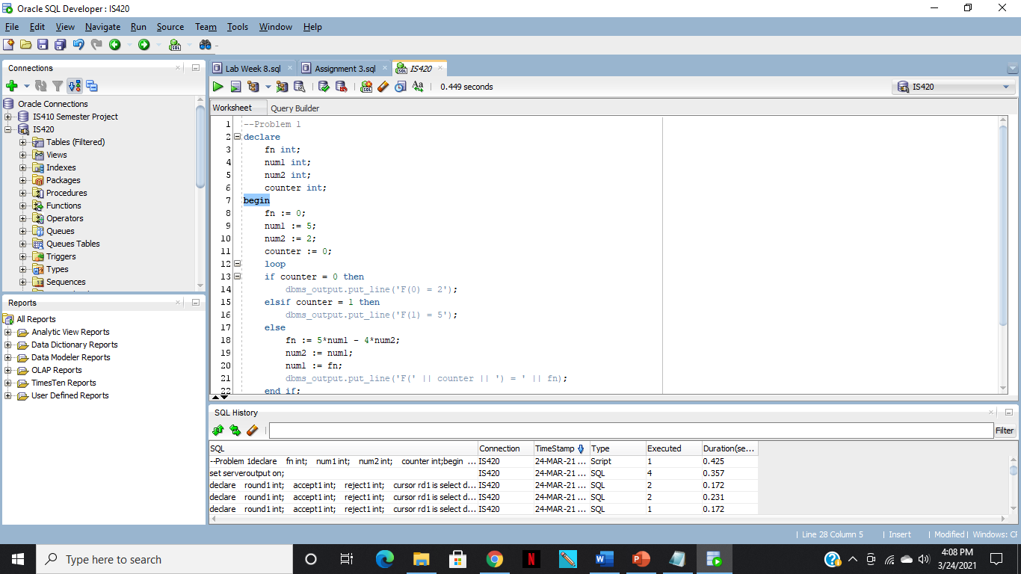

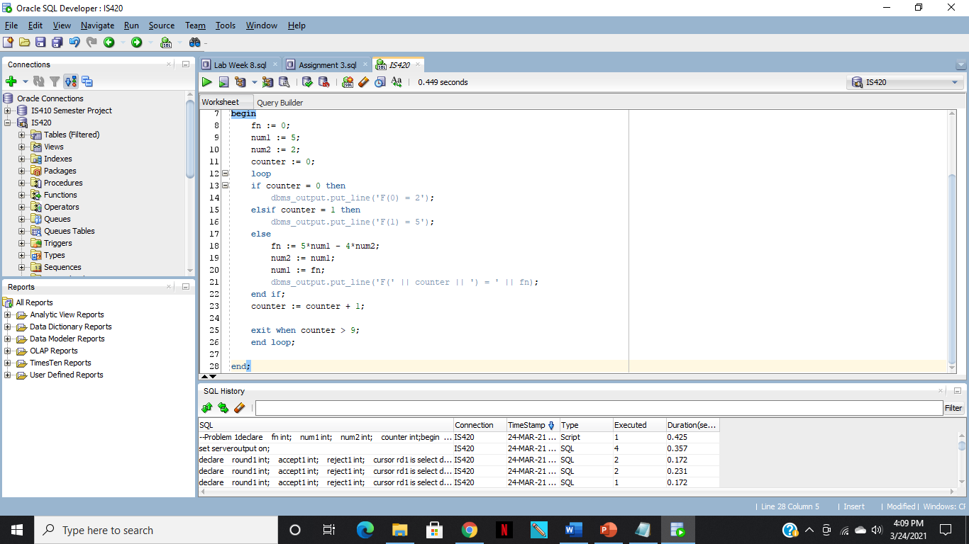

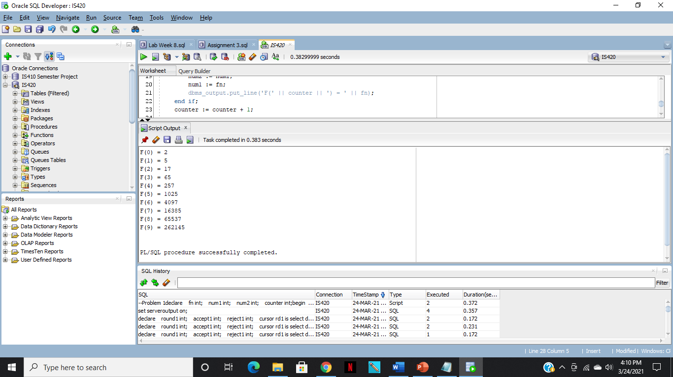

**Code:**

--Problem 1

declare

fn int;

num1 int;

num2 int;

counter int;

begin

fn := 0;

num1 := 5;

num2 := 2;

counter := 0;

loop

if counter = 0 then

dbms_output.put_line('F(0) = 2');

elsif counter = 1 then

dbms_output.put_line('F(1) = 5');

else

fn := 5*num1 - 4*num2;

num2 := num1;

num1 := fn;

dbms_output.put_line('F(' || counter || ') = ' || fn);

end if;

counter := counter + 1;

exit when counter > 9;

end loop;

end;

Problem 2: Write anonymous PL/SQL code to print out number of reviewers who have NOT submitted round 1 review for the paper titled 'A novel approach of mining EHR data'.

Hint: a review is not submitted if the receive_date column in paper_review table is null.

[30 points]

**Screenshots:**

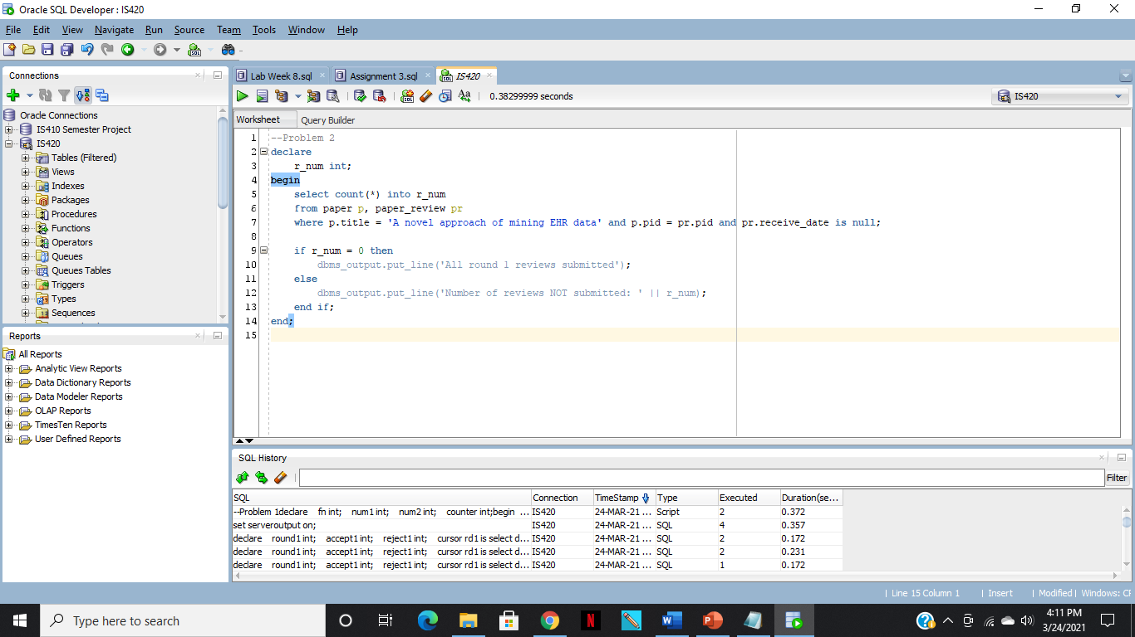

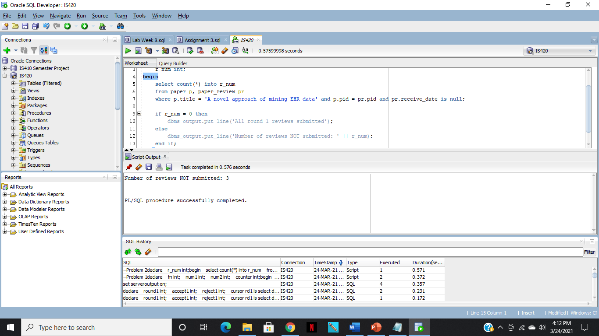

**Code:**

--Problem 2

declare

r_num int;

begin

select count(*) into r_num

from paper p, paper_review pr

where p.title = 'A novel approach of mining EHR data' and p.pid = pr.pid and pr.receive_date is null;

if r_num = 0 then

dbms_output.put_line('All round 1 reviews submitted');

else

dbms_output.put_line('Number of reviews NOT submitted: ' || r_num);

end if;

end;

Problem 3: [40 points] Write an anonymous PL/SQL program to print out review decision and comments for round 1 review of paper titled 'Comparing big data systems'. In the same program, please also print out an automatic suggestion for this paper.

The suggestion should be 'reject' if at least two reviewers' decisions are

reject. The suggestion should be 'accept' if all reviewers' decisions are accept. All other cases the suggestion is 'to be decided by editor'.

Hint: you can use an explicit cursor to print out the review decision and comments, and a few implicit cursors to compute number of round 1 review for that paper, number of accept and number of reject decisions, and use if then else to come up with suggestion.

**Screenshots:**

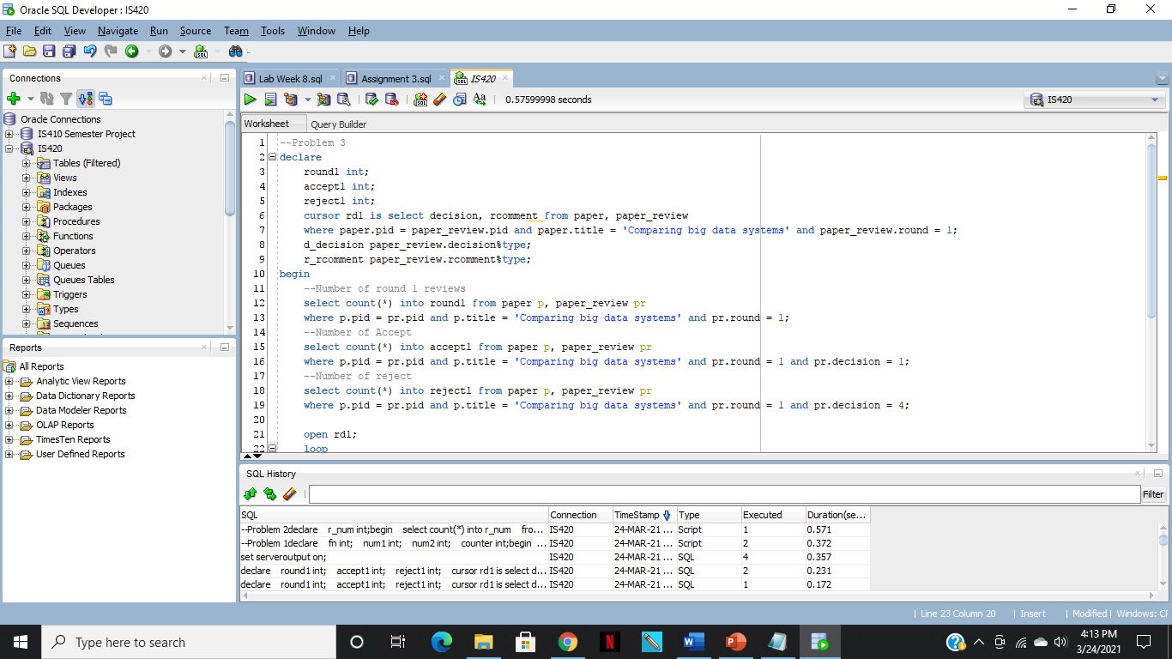

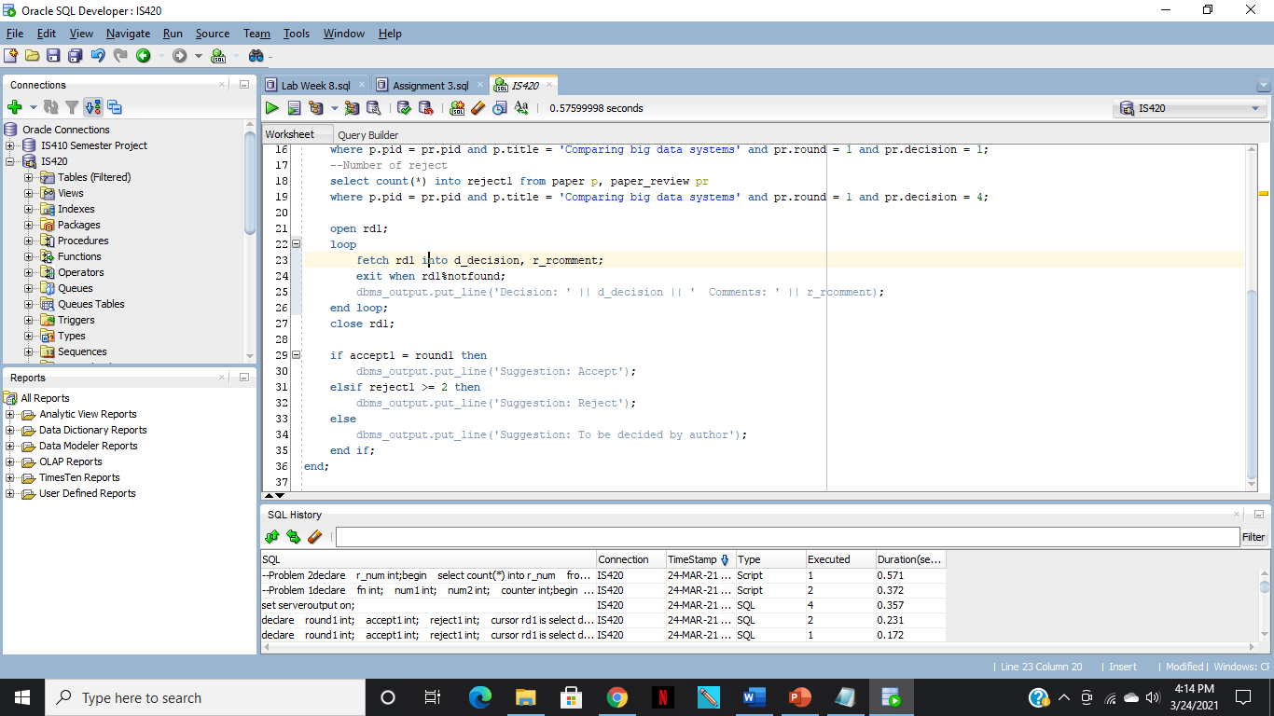

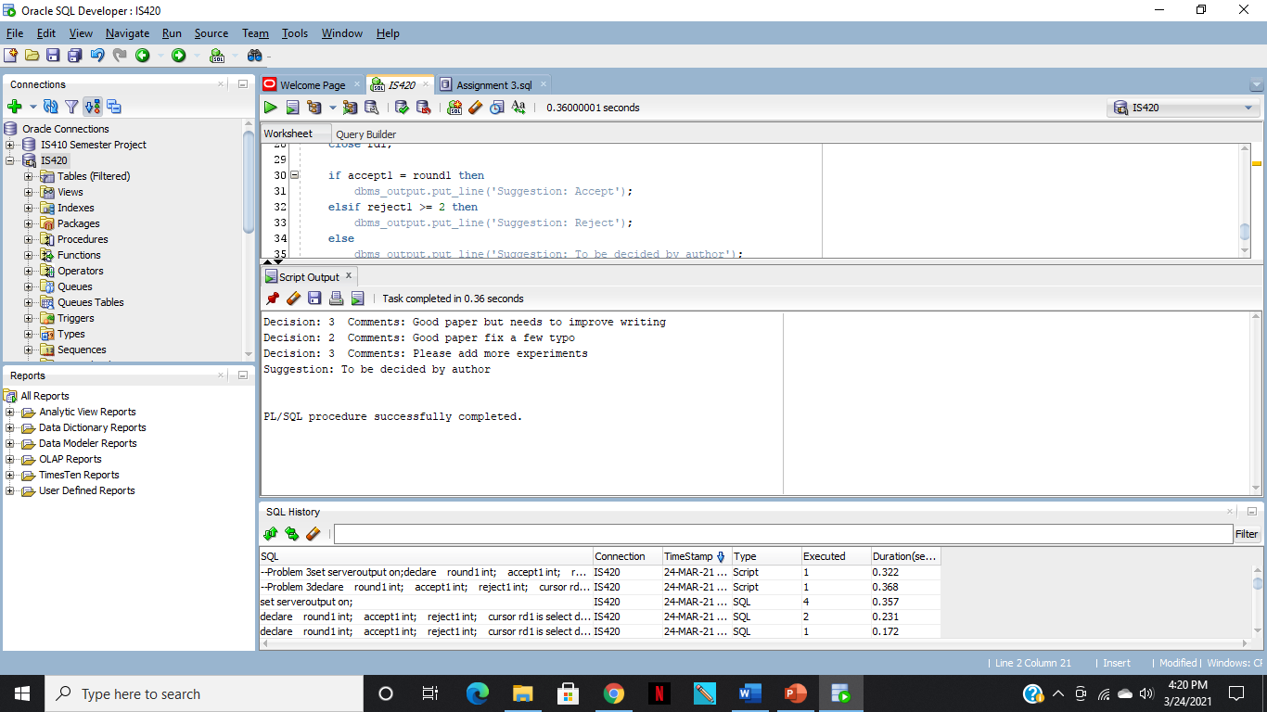

**Code:**

--Problem 3

declare

round1 int;

accept1 int;

reject1 int;

cursor rd1 is select decision, rcomment from paper, paper_review

where paper.pid = paper_review.pid and paper.title = 'Comparing big data systems' and paper_review.round = 1;

d_decision paper_review.decision%type;

r_rcomment paper_review.rcomment%type;

begin

--Number of round 1 reviews

select count(*) into round1 from paper p, paper_review pr

where p.pid = pr.pid and p.title = 'Comparing big data systems' and pr.round = 1;

--Number of Accept

select count(*) into accept1 from paper p, paper_review pr

where p.pid = pr.pid and p.title = 'Comparing big data systems' and pr.round = 1 and pr.decision = 1;

--Number of reject

select count(*) into reject1 from paper p, paper_review pr

where p.pid = pr.pid and p.title = 'Comparing big data systems' and pr.round = 1 and pr.decision = 4;

open rd1;

loop

fetch rd1 into d_decision, r_rcomment;

exit when rd1%notfound;

dbms_output.put_line('Decision: ' || d_decision || ' Comments: ' || r_rcomment);

end loop;

close rd1;

if accept1 = round1 then

dbms_output.put_line('Suggestion: Accept');

elsif reject1 >= 2 then

dbms_output.put_line('Suggestion: Reject');

else

dbms_output.put_line('Suggestion: To be decided by author');

end if;

end;